**Unveiling Alice Kelly recognition plaque**

**16-11-2017**

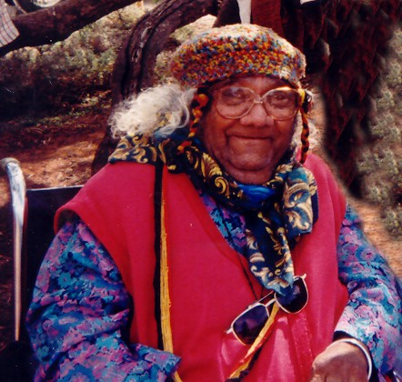**Discovery Centre Balranald**

In 1919 a child was born on the banks of Murrumbidgee. In Balranald on Mutthi Mutthi country, at the place we call the Dippo. Her placenta would have been wrapped in ash and bark and buried beneath a tree. A ritual, that gives thanks to mother earth the source of all life. The old people believed from that place, a tree would grow. So when we walk on this land, we must be careful because a child was born here.

This child was named Alice Ellen Pearce (Kelly), a Mutthi Mutthi women destined to be the Keeper of Culture, Law and Language. A woman who breathed life into the dry bones of her Ancestors, bringing back the dignity and recognition of the sacredness of the secrets that hold giving life, to clans and tribes today. From Nan’s work also came the realisation by the scientific world that they now had to stop and view the ancient occupation of this land, through a new lens.

Nan held a great belief in the possibilities that education could provide; particularly in the area of early childhood development. She became part of a courageous group of Aboriginal Elders who would also change the mindset of the educational world. From her humble home in 82 O’Connor Street, Alice Kelly’s name became known out there. Throughout many Governmental Educational Departments and Communities, she was known as the woman you need to talk to.

One example I would like to share; in the state of NSW before 1972 the same year my cousin Jason was born, the man that lead us through ceremony at the cemetery today. The NSW department of education had the right to refuse Aboriginal children entry into public schools. This changed because of people like Alice Kelly.Nan continued to be a part of a strong group of Aboriginal Elders known as AFEC. A grass root movement for educational change for Aboriginal children and future generations that brought this piece of legislation to fruition.

Nan was a woman of the Catholic faith and she challenged the church in 1988 when she wrote to the Bishops in Australia from her humble home

*“I have many concerns for my people arising from the dislocation caused by European invasion and from the position of our people in this society today. I have long and patiently awaited this moment for my family and my people when they would come together in their Aboriginality and their baptism to say to the Church “We are Aboriginal. We are baptised Catholics. We have been invisible to the Church in Australia. The Church has been absent from our lives but in our hearts we deeply experience our baptism and our faith in Jesus … We want to see the spirit of our people and Jesus come together. I have been expressing this deep concern to my family and their children, my longing for my grandchildren and great-grandchildren. …. It is this circumstance that I speak to my non-Aboriginal brothers and sisters and you, Bishop and hierarchy of the Catholic Church, soliciting aid to restore to my own people and youth an experience of their spirituality that will blend with their baptism and responsibility to their brothers and sisters and the wider community.”*

I have no doubt there were many Aboriginal people who were just as worthy to receive the ‘Aboriginal Person of the Year Award’ in the Bicentenary year of 1988, but in receiving this award Nan confirmed what we all know. Now where we all stand today we know, we have a home grown legend, a true salt of the earth; that will never be forgotten - Alice Kelly and her husband Alf Kelly, for he was her rock.

All of Nan’s work came with no financial recompense of any kind and all the while she continued as the matriarch of an ever growing extended family. Accumulating material possessions was never part of her ethos. Instead Nan sought justice, peace and equality for all people.

Nan probably never knew it, but she always held the trump card. There is no way the Lake Mungo would have received the UNESCO status in 1981 without her and there is no way Lake Mungo would have received its World Heritage status without the continuing work of her descendants and extended family. All the scientist and government bodies at that time knew they could not continue their work unless there was an act of justice. So today we are witnessing one of the acts of justice and one of the proudest moments for us Kelly gang. May this town and its folk be proud too and celebrate this proud humble tribal women and the incredible legacy this women, our Nan and true matriarch has bestowed upon us.

Nan always believed that among the many gifts we Aboriginal People bring, that the antiquity and cultural heritage that Mungo has to offer Australia, is the gift of love, peace and harmony. We only, as a nation, need to stop, listen and receive the gift. Lake Mungo is a true national treasure!

**Written by: Vicki Clark**

**Alice Kelly granddaughter**

